

Video Cloud SharePoint Integration
Installation and Administrative Guide

Produced for Brightcove by:


Document Version: 2.0
Date: January 9, 2013

Installing the Brightcove Video Cloud Integration Feature
Complete the following steps to install the Brightcove Video Cloud Integration Feature:
- Unzip the Brightcove Video Cloud Integration package. Create an empty folder on your SharePoint server (e.g., "c:\Brightcove\") and unzip the package into the folder. This will create the following files:
  - BrightcoveSDK.dll
  - Cycle-SPVideoCloud.ps1
  - Install-Solution.ps1
  - BrightcoveVideoCloudIntegration.wsp
  - Uninstall-Solution.ps1
  - Brightcove SharePoint Integration Installation Guide.doc (this file)
- Edit "Cycle-SPVideoCloud.ps1" in a text editor. Make the following changes:
  - Change the "Set-Location" value to the folder from Step #1 (e.g. "c:\Brightcove\").
  - Change the "WebSiteUrl" parameter to the root of your site collection (e.g. "http://localhost/").
  - If you have your Brightcove information available, change the parameter “BCPublisherId”, “BCReadToken”, “BCWriteToken” “BCVideoPlayerId” and “BCPlaylistPlayerId” to their appropriate values as specified on page 3; otherwise just leave them blank.
- Execute "Cycle-SPVideoCloud.ps1". On your SharePoint server, open a SharePoint Management Shell window as an administrator. Execute the following command:
.\Cycle-SPVideoCloud.ps1
NOTE: Manual installation instructions are provided at the end of this document for those who wish to forego the use of the automated script or to trouble shoot installation issues.
- Add users to the "Brightcove Administrators" SharePoint group who should be able to upload videos and make changes in your Brightcove account. When you activate the Brightcove Video Cloud Integration Feature this group is created automatically. Use SharePoint's built-in interface to give users and groups permissions to your Brightcove account by adding them to the "Brightcove Administrators" SharePoint group.
NOTE: This group should be created when the site collection feature is activated. If it did not get created then you will need to create the group manually from the root of the site. Be sure to add the users that will need access to the Brightcove editing web parts.
The Brightcove Video Cloud Integration Feature is now installed and activated. In the next section, you will configure the feature with your company's Brightcove account information.

Configuring the Brightcove Video Cloud Integration Feature
Complete the following steps to configure the Brightcove Video Cloud Integration Feature on your SharePoint Server 2010 environment:
- Open the site where you installed the feature using SharePoint Designer 2010.
- Click the "Site Options" button on the SharePoint ribbon.
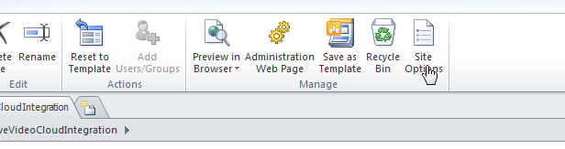
- In the "Site Options" dialog, select the "Parameters" tab and create/modify the following Name and Value pairs:
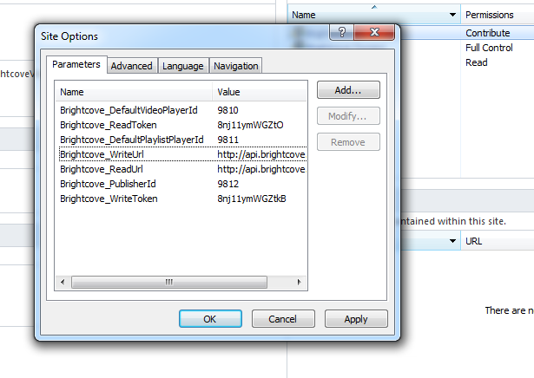
Brightcove_DefaultVideoPlayerId: This value stores the ID of a Brightcove video player. The default video player is used when visitors to your site are previewing videos from the search results page. Set this value to one of your Brightcove account's video Player IDs.
Brightcove_ReadToken: This value is the Read Token(s) for your Brightcove account. If you would like to use more than one, place a comma between the tokens (e.g., "xxx,yyy,zzz").
Brightcove_DefaultPlaylistPlayerId: This value stores the ID of a Brightcove Video Player with a Tabbed Playlist. The default playlist player is used when visitors to your site are previewing playlists from the playlist browse page. Set this value to the ID of one of your Brightcove account's Video Players with a Tabbed Playlist.
Brightcove_WriteUrl: This URL identifies the location of the Brightcove Write API. The value for this field should be: http://api.brightcove.com/services/post
Brightcove_ReadUrl: This URL identifies the location of the Brightcove Read API. The value for this field should be: http://api.brightcove.com/services/library
Brightcove_PublisherId: This value is the Publisher ID for your Brightcove account.
Brightcove_WriteToken: This value is the Write Token(s) for your Brightcove account. If you would like to use more than one, place a comma between the tokens (e.g., "xxx,yyy,zzz").

The Brightcove Video Cloud Integration Feature is now properly configured.
NOTE: If the web parts do not render correctly, ensure that the Brightcove properties contain valid values and deactive and then active the web site feature called “Brightcove Video Cloud Integration Demo”.

Brightcove Video Cloud Integration Demo Site
The Brightcove Video Cloud Integration Feature installs a demonstration site. The demo site shows the use of the Brightcove Video Cloud API from SharePoint Server 2010. The Brightcove API contains dozens of methods that allow you to upload and tag videos, search and preview videos, publish videos to websites, create and manage playlists, and perform other video-related tasks. This site uses many of these API methods to demonstrate four main features of the Brightcove Video Cloud service.
To start your tour of the Brightcove Video Cloud Integration Feature, use your browser to navigate to the "Demo" library that you created during Step #2 of the automated installation. If the feature is installed properly, this library will be filled with sample pages. Open the "Default.aspx" page in your browser.

Brightcove Video Cloud Integration Web Part Descriptions
The Brightcove Video Cloud Integration Feature contains five web parts that use your Brightcove account information to upload and tag videos, search and preview videos, publish videos to websites, and create and manage playlists. Each web part is described in its own section below.
At its most basic level, this SharePoint Feature is simply an encapsulation of the Brightcove API packaged in an easy-to-use, SharePoint-accessible set of web parts. Please refer to the Brightcove API documentation for more details about the capabilities of the Brightcove Video Cloud service.

Brightcove Video Cloud Search
The Brightcove Video Cloud Search web part is used for searching for videos in your Brightcove account. You can search for the video by name, short description, long description, tags, and custom fields. Authorized users will also see a link that will allow them to edit each video.
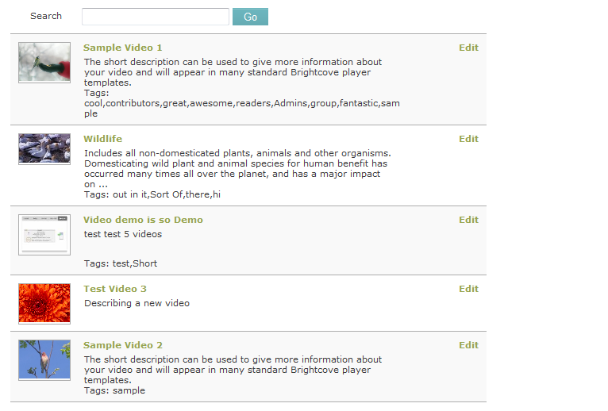
This screen shot shows the Brightcove Video Cloud Search web part in use by an authorized user.
In addition to the default SharePoint web part configurations, the Brightcove Video Cloud Search web part has the following Brightcove Configurations:
Play Video Link: This value identifies the location of a web page that contains the Brightcove Video Cloud Player web part. In the demo site the value uses JavaScript to open VideoPlayer.aspx in a SharePoint pop-up window.
Edit Video Link: This value identifies the location of a web page that contains the Brightcove Video Cloud Editor web part. In the demo site the value uses JavaScript to open VideoEditor.aspx in a SharePoint pop-up window.
Custom Field(s): This value contains a comma-delimited list of the names of any custom fields that you have configured in your Brightcove account that you want visitors to be able to use when searching.

Brightcove Video Cloud Editor
The Brightcove Video Cloud Editor web part allows authorized users to upload, edit, and delete videos from your Brightcove account. In "Upload" mode, users can upload up to five videos with the same basic metadata. In "Edit" mode, users can edit one video at a time.
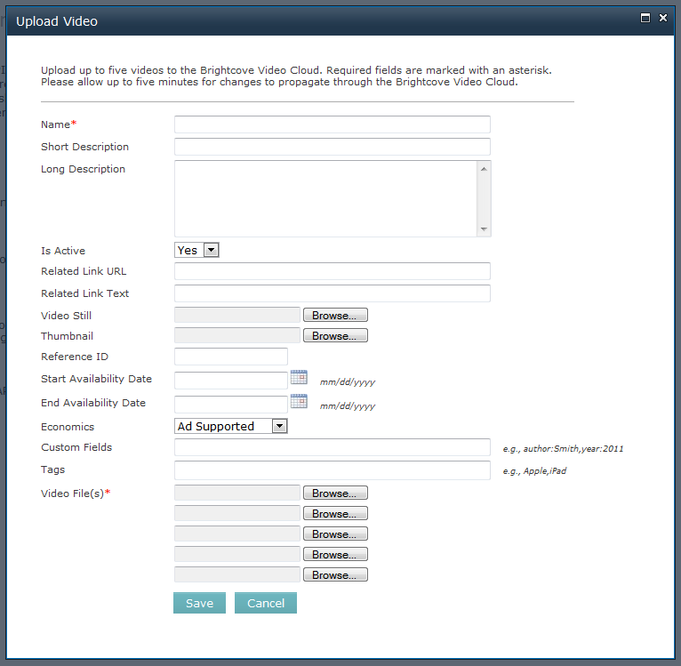
This screen shot shows the Brightcove Video Cloud Editor web part in "Upload" mode.
The Brightcove Video Cloud Editor web part does not have any Brightcove-specific configurations.

Brightcove Video Cloud Player
The Brightcove Video Cloud Player web part plays a video (or playlist) from your Brightcove account. This web part can play either a single video or a playlist.
You can configure the web part to use a specific player by setting its Player Id configuration. If no player is specified, the web part uses one of the default Player IDs for the site (see the "Configuring the Brightcove Video Cloud Integration Feature" section above for more information).
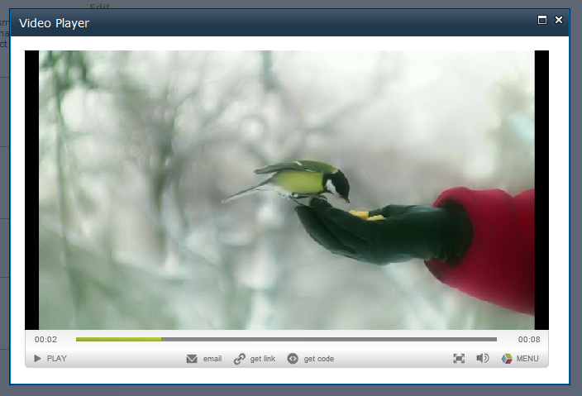
This screen shot shows the Brightcove Video Cloud Player playing a single video.
In addition to the default SharePoint web part configurations, the Brightcove Video Cloud Player web part has the following Brightcove Configurations:
Background Color: This value sets the background color of the player. You will see only this color if the video is smaller than the player area. The default value is #FFFFFF.
Player Width: This value sets the width of the player. The default value is 640.
Player Height: This value sets the height of the player. The default value is 390.
Player Id: This value determines the player that will be used to play the video. The default value is blank. If the value is blank, the value in the Brightcove_DefaultVideoPlayerId setting will be used to play a video or the Brightcove_DefaultPlaylistPlayerId setting will be used to play a playlist.
Auto Start: This checkbox determines whether the video will start as soon as the web page loads. The default value is unchecked (False).
Video ID: This value determines which video will be played. The default value is blank.
Playlist ID: This value determines which playlist will be played. The default value is blank. If this value is set and the Video ID value is set, the playlist will be played instead of the video.

Brightcove Video Cloud Playlist
The Brightcove Video Cloud Playlist web part displays the list of playlists that have been created in your Brightcove account. The playlists are shown in descending date order with the most recent playlist at the top of the list.
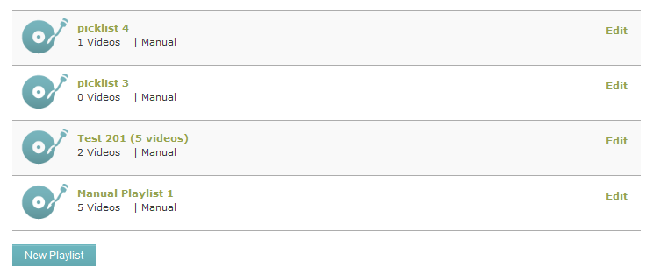
This screen shot shows the Brightcove Video Cloud Playlist web part in use by an authorized user.
In addition to the default SharePoint web part configurations, the Brightcove Playlist Browser web part has the following Brightcove Configurations:
Play Playlist Link: This value identifies the location of a web page that contains the Brightcove Video Cloud Player web part. In the demo site the value uses JavaScript to open PlaylistPlayer.aspx in a SharePoint pop-up window.
Edit Playlist Link: This value identifies the location of a web page that contains the Brightcove Video Cloud Playlist web part and Brightcove Video Cloud Picklist web part. In the demo site the value uses JavaScript to open PlaylistEditor.aspx in a SharePoint pop-up window.
Brightcove Video Cloud Picklist
The Brightcove Video Cloud Picklist web part allows authorized users to create and edit playlists. Authorized users can manually search for videos and add them to a playlist in a specific order, or they can create a "smart playlist" that is built automatically based on specific keywords.
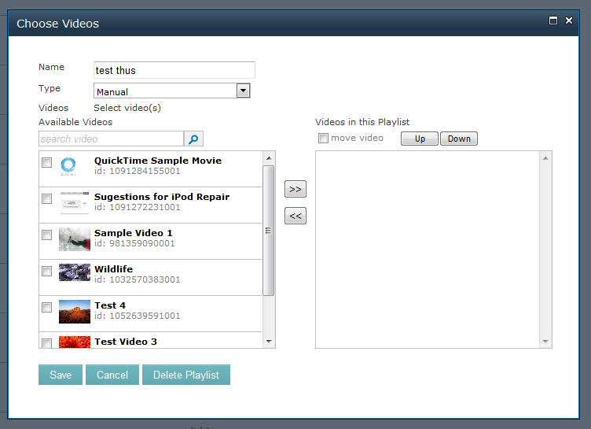
This screen shot shows the Brightcove Video Cloud Picklist web part in use by an authorized user.
The Brightcove Playlist Editor web part does not have any Brightcove-specific configurations.

Manual Installation Instruction for the Brightcove Video Cloud Feature
The following steps are provided to allow SharePoint administrators to manually install the required components instead of relying of the PowerShell installation script. These instructions can also be used to assist in trouble shooting any errors during installation and do not rely on PowerShell.
- Unzip the Brightcove Video Cloud Integration package. Create an empty folder on your SharePoint server (e.g., "c:\Brightcove\") and unzip the package into the folder. This will create the following files:
  - BrightcoveSDK.dll
  - Cycle-SPVideoCloud.ps1 (not used for manual installation)
  - Install-Solution.ps1 (not used for manual installation)
  - BrightcoveVideoCloudIntegration.wsp
  - Uninstall-Solution.ps1 (not used for manual installation)
  - Brightcove SharePoint Integration Installation Guide.doc (this file)
- Add the "BrightcoveSDK.dll" to the Global Assembly Cache. On your SharePoint server, open a command window as an administrator and execute the following command from the c:\brightcove directory:
"C:\Program Files (x86)\Microsoft SDKs\Windows\v7.0A\Bin\gacutil" /i BrightcoveSDK.dll
NOTE: The location of the gacutil.exe utility is based on your server's operating system version. Search for "gacutil.exe" and update the path above. You may have more than one copy of gacutil on your system. Use the most recent version.

- Install the Solution into the SharePoint Farm. On your SharePoint server, open a command window as an administrator and execute the following command from the c:\brightcove directory:
"C:\Program Files\Common Files\Microsoft Shared\Web Server Extensions\14\BIN\stsadm.exe" -o addsolution -filename BrightcoveVideoCloudIntegration.wsp
NOTE: The location of the stsadm.exe utility is based on location of where SharePoint was installed.
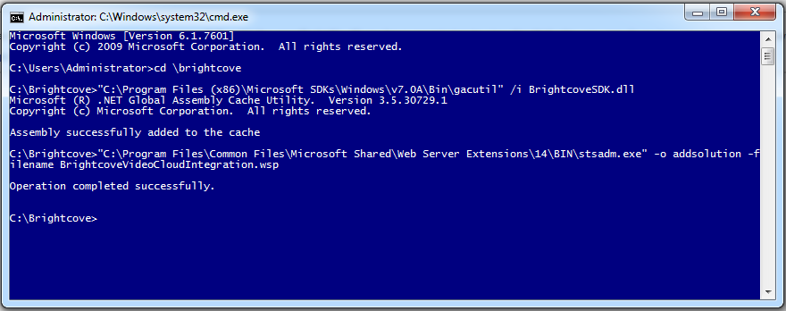

- Deploy the brightcovevideocloudintegration.wsp solution to a web application. From the Central Administration web site, navigate to the “Manage farm solutions” and deploy the brightcovevideocloudintegration.wsp solution to the web application that contains the site collection where the demo will be installed.

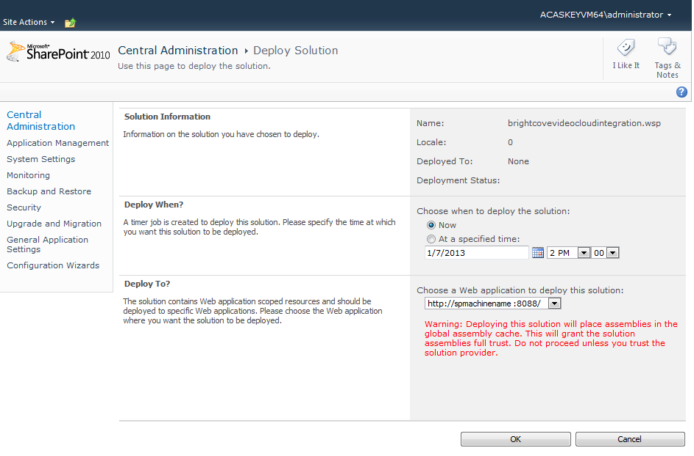

NOTE: Ensure that the target site collection has been fully provisioned before deploying the solution to the web application. This will help ensure that the web parts and site properties are properly added.

- Create a document library called "Demo" in the site where you plan to activate the “Brightcove Video Cloud Integration Demo” feature. When the feature is activated, this library will be populated with style sheets, scripts, images and example pages that show the web parts in action.
- Activate the Brightcove Video Cloud Integration Site Collection Feature which will install the web parts that are used to integrate with Brightcove. On the "Site Settings" page, choose “Site collection features" in the "Site Collection Administration" section and activate the feature called "Brightcove Video Cloud Integration".
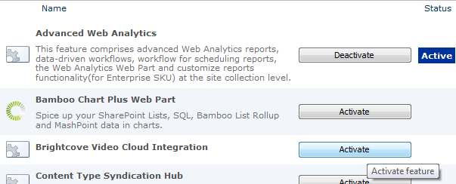

- Activate the Brightcove Video Cloud Integration Demo Site Feature which will install the demo files in the “Demo” document library. On the "Site Settings" page, choose "Manage site features" in the "Site Actions" section and activate the feature called "Brightcove Video Cloud Integration Demo".

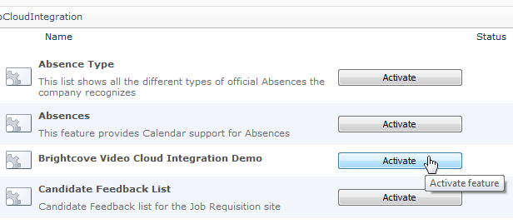
NOTE: Activating the “Brightcove Video Cloud Integration Demo” prior to creating the Demo document library will create a folder called “Demo”, which will only be visible in SharePoint Designer, and you will see an error similar to:
Failed to instantiate file "style1.css" from module "Demo": The specified list does not exist.
If you get this error, you will first have to delete the “Demo” folder using SharePoint Designer before creating a Document Library called “Demo”. If you create a document library before deleting this folder, SharePoint will create the library with a relative url of “demo1” instead of “demo” and you will not be able to activate the feature.
- Add users to the "Brightcove Administrators" SharePoint group who should be able to upload videos and make changes in your Brightcove account. When you activate the Brightcove Video Cloud Integration Feature this group is created automatically. Use SharePoint's built-in interface to give users and groups permissions to your Brightcove account by adding them to the "Brightcove Administrators" SharePoint group.
NOTE: This group should be created when the site collection feature is activated. If it did not get created then you will need to create the group manually from the root of the site. Be sure to add the users that will need access to the Brightcove editing web parts.

The Brightcove Video Cloud Integration Feature is now installed and activated. Refer back to the section “Configuring the Brightcove Video Cloud Integration Feature” on page 3 to configure the feature with your company's Brightcove account information.

